Log Analysis Using Regular Expressions

**Introduction**

Imagine your company uses a server that runs a service called *ticky*, an internal ticketing system. The service logs events to syslog, both when it runs successfully and when it encounters errors.

The service's developers need your help getting some information from those logs so that they can better understand how their software is used and how to improve it. So, for this lab, you'll write some automation scripts that will process the system log and generate reports based on the information extracted from the log files.

**What you'll do**

* Use regex to parse a log file
* Append and modify values in a dictionary
* Write to a file in CSV format
* Move files to the appropriate directory for use with the CSV->HTML converter

You'll have 90 minutes to complete this lab.

**Exercise - 1**

We'll be working with a log file named **syslog.log**, which contains logs related to *ticky*.

You can view this file using:

cat syslog.log

The log lines follow a pattern similar to the ones we've seen before. Something like this:

May 27 11:45:40 ubuntu.local ticky: INFO: Created ticket [#1234] (username)

Jun 1 11:06:48 ubuntu.local ticky: ERROR: Connection to DB failed (username)

When the service runs correctly, it logs an INFO message to syslog. It then states what it did and states the username and ticket number related to the event. If the service encounters a problem, it logs an ERROR message to syslog. This error message indicates what was wrong and states the username that triggered the action that caused the problem.

In this section, we'll search and view different types of error messages. The error messages for *ticky* details the problems with the file with a timestamp for when each problem occurred.

These are a few kinds of listed error:

* Timeout while retrieving information
* The ticket was modified while updating
* Connection to DB failed
* Tried to add information to a closed ticket
* Permission denied while closing ticket
* Ticket doesn't exist

To grep all the logs from *ticky*, use the following command:

grep ticky syslog.log

Output:

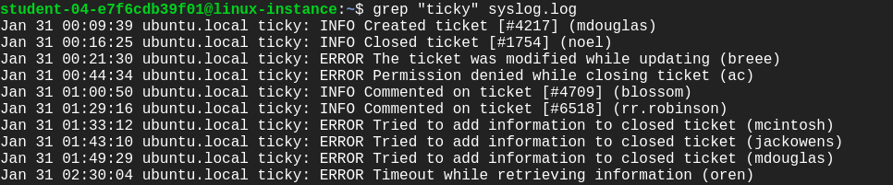

In order to search all the **ERROR** logs, use the following command:

grep "ERROR" syslog.log

Output:

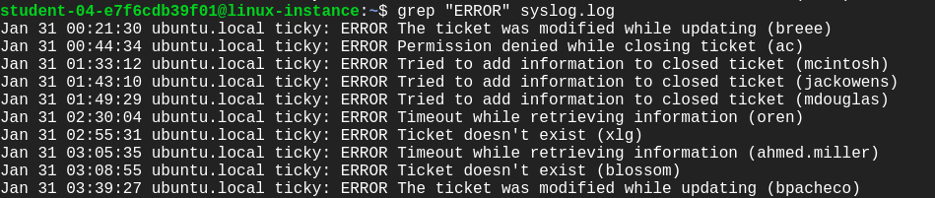

To enlist all the ERROR messages of specific kind use the below syntax.

**Syntax:** grep ERROR [message] [file-name]

grep "ERROR Tried to add information to closed ticket" syslog.log

Output:

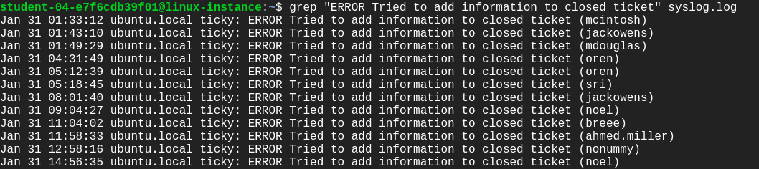

Let's now write a few regular expressions using a python3 interpreter.

We can also grep the ERROR/INFO messages in a pythonic way using a regular expression. Let's now write a few regular expressions using a **python3** interpreter.

Open **Python shell** using the command below:

python3

This opens a **Shell**. Python provides a **Python Shell** (also known as **Python** Interactive **Shell**), which is used to execute a single **Python** command and get the result.

Import the regular expression module (re).

import re

line = "May 27 11:45:40 ubuntu.local ticky: INFO: Created ticket [#1234] (username)"

To match a string stored in **line** variable, we use the search() method by defining a pattern.

re.search(r"ticky: INFO: ([\w ]*) ", line)

Output:

<re.Match object; span=(29, 57), match='ticky: INFO: Created ticket '>

You can also get the **ERROR** message as we did for the **INFO** log above from the ERROR log line.

line = "May 27 11:45:40 ubuntu.local ticky: ERROR: Error creating ticket [#1234] (username)"

To match a string stored in a **line** variable, we use the search() method by defining a pattern.

re.search(r"ticky: ERROR: ([\w ]*) ", line)

Output:

<re.Match object; span=(29, 65), match='ticky: ERROR: Error creating ticket '>

Now that you know how to use regular expressions with Python, start fetching logs of *ticky* for a specific username. We'll need them in later sections.

**Exercise - 2**

Now, use the Python interactive shell to create a dictionary.

fruit = {"oranges": 3, "apples": 5, "bananas": 7, "pears": 2}

Call the sorted function to sort the items in the dictionary.

sorted(fruit.items())

Output:

[('apples', 5), ('bananas', 7), ('oranges', 3), ('pears', 2)]

We'll now sort the dictionary using the item's key. For this use the **operator** module.

Pass the function itemgetter() as an argument to the sorted() function. Since the second element of tuple needs to be sorted, pass the argument 0 to the itemgetter function of the **operator** module.

import operator

sorted(fruit.items(), key=operator.itemgetter(0))

Output:

[('apples', 5), ('bananas', 7), ('oranges', 3), ('pears', 2)]

To sort a dictionary based on its **values**, pass the argument 1 to the itemgetter function of the **operator** module.

sorted(fruit.items(), key=operator.itemgetter(1))

Output:

[('pears', 2), ('oranges', 3), ('apples', 5), ('bananas', 7)]

Finally, you can also reverse the order of the sort using the **reverse** parameter. This parameter takes in a boolean argument.

To sort the fruit object from most to least occurrence, we pass the argument reverse=True.

sorted(fruit.items(), key = operator.itemgetter(1), reverse=True)

Output:

[('bananas', 7), ('apples', 5), ('oranges', 3), ('pears', 2)]

You can see the fruit object is now sorted from the most to the least number of occurrences.

Great job practice these skills! You can further practice this by sorting the logs that you would fetch using regular expressions from the previous section.

Exit the shell using exit().

**Exercise - 3**

We'll now work with a file named **csv_to_html.py**. This file converts the data in a CSV file into an HTML file that contains a table with the data. Let's practice this with an example file.

Create a new CSV file.

nano user_emails.csv

Add the following data into the file:

Full Name, Email Address

Blossom Gill, blossom@abc.edu

Hayes Delgado, nonummy@utnisia.com

Petra Jones, ac@abc.edu

Oleg Noel, noel@liberomauris.ca

Ahmed Miller, ahmed.miller@nequenonquam.co.uk

Macaulay Douglas, mdouglas@abc.edu

Aurora Grant, enim.non@abc.edu

Madison Mcintosh, mcintosh@nisiaenean.net

Montana Powell, montanap@semmagna.org

Rogan Robinson, rr.robinson@abc.edu

Simon Rivera, sri@abc.edu

Benedict Pacheco, bpacheco@abc.edu

Maisie Hendrix, mai.hendrix@abc.edu

Xaviera Gould, xlg@utnisia.net

Oren Rollins, oren@semmagna.com

Flavia Santiago, flavia@utnisia.net

Jackson Owens, jackowens@abc.edu

Britanni Humphrey, britanni@ut.net

Kirk Nixon, kirknixon@abc.edu

Bree Campbell, breee@utnisia.net

Save the file by clicking Ctrl-o, Enter key, and Ctrl-x.

Give executable permission to the script file **csv_to_html.py**.

sudo chmod +x csv_to_html.py

To visualize the data in the **user_emails.csv** file, you have to generate a webpage that'll be served by the webserver running on the machine.

The script **csv_to_html.py** takes in two arguments, the CSV file, and location that would host the HTML page generated. Give write permission to the directory that would host that HTML page:

sudo chmod o+w /var/www/html

Next, run the script **csv_to_html.py** script by passing two arguments: user_emails.csv file and the path /var/www/html/. Also, append a name to the path with an HTML extension. This should be the name that you want the HTML file to be created with.

./csv_to_html.py user_emails.csv /var/www/html/<html-filename>.html

Replace <html-filename> with the new name.

Navigate to the /var/www/html directory. Here, you'll find an HTML file created with the filename you passed to the above script.

ls /var/www/html

Now, to view this HTML page, open any web-browser and enter the following URL in the search bar.

**[linux-instance-external-IP]**/**[html-filename].html**

Output:

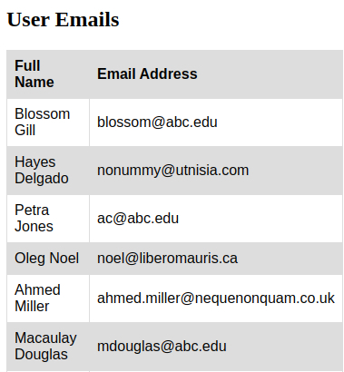

You should now be able to visualize the data within the user_emails.csv file on a webpage.

**Generate reports**

Now, we're going to practice creating a script, named **ticky_check.py**, that generates two different reports from this internal ticketing system log file i.e., syslog.log. This script will create the following reports:

* **The ranking of errors generated by the system**: A list of all the error messages logged and how many times each error was found, sorted by the most common error to the least common error. This report doesn't take into account the users involved.
* **The user usage statistics for the service**: A list of all users that have used the system, including how many info messages and how many error messages they've generated. This report is sorted by username.

To create these reports write a python script named ticky_check.py. Use nano editor for this.

nano ticky_check.py

Add the shebang line.

#!/usr/bin/env python3

Here's your challenge: Write a script to generate two different reports based on the ranking of errors generated by the system and the user usage statistics for the service. You'll write the script on your own, but we'll guide you throughout.

First, import all the Python modules that you'll use in this Python script. After importing the necessary modules, initialize two dictionaries: one for the number of different error messages and another to count the number of entries for each user (splitting between INFO and ERROR).

Now, parse through each log entry in the syslog.log file by iterating over the file.

For each log entry, you'll have to first check if it matches the **INFO** or **ERROR** message formats. You should use regular expressions for this. When you get a successful match, add one to the corresponding value in the per_user dictionary. If you get an **ERROR** message, add one to the corresponding entry in the error dictionary by using proper data structure.

After you've processed the log entries from the syslog.log file, you need to sort both the per_user and error dictionary before creating CSV report files.

Keep in mind that:

* The error dictionary should be sorted by the number of errors from most common to least common.
* The user dictionary should be sorted by username.

Insert column names as ("Error", "Count") at the zero index position of the sorted error dictionary. And insert column names as ("Username", "INFO", "ERROR") at the zero index position of the sorted per_user dictionary.

After sorting these dictionaries, store them in two different files: **error_message.csv** and **user_statistics.csv**.

Save the **ticky_check.py** file by clicking Ctrl-o, Enter key, and Ctrl-x.

**Visualize reports**

First, give executable permission to the Python script ticky_check.py.

chmod +x ticky_check.py

Run the ticky_check.py by using the following command:

./ticky_check.py

Executing ticky_check.py will generate two report file __error_message.csv __and **user_statistics.csv**.

You can now visualize the __error_message.csv __and **user_statistics.csv** by converting them to HTML pages. To do this, pass the files one by one to the script **csv_to _html.py** file, like we did in the previous section.

To convert the **error_message.csv** into HTML file run the following command:

./csv_to_html.py error_message.csv /var/www/html/<html-filename>.html

Replace <html-filename> with the name of your choice.

To convert **user_statistics.csv** into HTML file, run the following command:

./csv_to_html.py user_statistics.csv /var/www/html/<html-filename>.html

Replace <html-filename> with the new name

Now, to view these HTML pages, open any web-browser and enter the following URL in the search bar.

**[linux-instance-external-IP]**/**[html-filename].html**

Output:

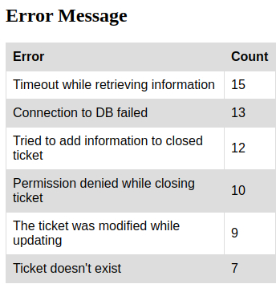

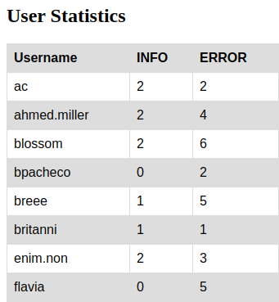

**Congratulations!**

Congrats! You've successfully written some automation scripts that process the system log and generate a bunch of reports based on the information extracted from the log files. You have also hosted these reports on a webpage. As an IT specialist, this will help you to work with Python scripting to generate HTML tabular data for data visualization.